Date …………………..

BOTULINUM TOXIN-A / H.A. DERMAL FILLER CLIENT CONSENT FORM

Name : D.O.B:
Address : Contact Number:

Questionnaire:
PLEASE STATE THE DATE YOU HAVE HAD YOUR COVID VACCINATION OR VACCINATION DUE:
1ST HAD/DUE ………………………………….. 2ND HAD/DUE …………….…………………..
HAVE YOU OR ANYONE IN YOUR HOUSEHOLD HAD COVID-19 ? …………..………………………………………………………………Yes/No
DO YOU OR ANYONE IN YOUR HOUSEHOLD SUSPECT THEY HAVE COVID-19? ……………………………………………………… Yes/No
Have you previously been treated with Dermal Fillers/PDO threads ? ……………………………………………………………………….. Yes/No
Details :……………………………………………………………………………………………………………………………………………………………………………………
Are you pregnant, breast feeding or trying to conceive (LMP) ? …………………………….……………………………………..…………...Yes/No
Any allergies/ had allergic reaction ? ......………………………………………………………………………………………………………..……..….…Yes/No
Any localized infection/cold sores? .....................……………………………………………………….…………………………………………....….. Yes/No
Details …………………………………………………………………………………………………………………………………………………….……………………………..
Do you suffer from any other medical conditions? ……………………………….……………….……….……………………………………..….… Yes/No
Details : ……………………………………………………………………………………………………………………………………………………………………………………
Suffer from CNS disease, neurological disorder, including migraine or epilepsy? …………………......……………………….……..Yes/No
Details …………………………………………………………………………………………………..………………………………………………………………………………..
Take any other medication (incl. over the counter or herbal medicines)? ……………………………...........……………………....…… Yes/No
Details……………………………………………………………………………………………………………………………………………………………………………………
Have you taken Aspirin/NSAIDs/Clopidogrel/Warfarin /Antibiotics recently? ..…….….………………………….………………..….... Yes/No

Do you consent to photographs being taken before and after treatment? ………………………………………………..……………….. Yes/No
These will not be used for promotional purposes without consent from the client.

THE FOLLOWING POTENTIAL ADVERSE EVENTS HAVE BEEN FULLY EXPLAINED AND UNDERSTOOD BY ME:
Possible side effects may include redness, swelling or stinging at injection sites, headaches, rash, temporary loss of movement of nearby muscles or localized numbness, bleeding, bruising, pain, itching, infection, discoloration, hypersensitivity and acne form papules at injection site.
Extreemly rare reports of blindness have been reported. The proportionate risk has been explained to me. I will advise my Practitioner should I experience any of the aforementioned adverse events and that I have made aware of any upcoming events that these side effects may have an impact on.
I am aware that these non-permanent dermal fillers are sterile gels containing non-animal hyaluronic acid and are designed to fill facial lines, facial contouring, lip augmentation or other areas of the body as agreed with my Practioner.
I confirm that to the best of my knowledge that the information that I have supplied is correct and that there are no other medical information that I need to disclose.
I consent to treatment with Hyaluronic Dermal Fillers and Botulinum Toxin-A, as discussed with my Practioner regarding the procedure I will be undertaking. I understand that more than one treatment session may be required to obtain maximum effects and no guarantee can be given as to the results of the treatment referred to in this document. I accept and understand that the goal of this treatment is improvement not perfection. I understand the information given, potential risks and that any medical terminology, questions or queries have been answered. I am aware of alterative treaments and that to have no treatment is one of those options.
I give permission that any prescription issued by Kama Clinical Services on behalf of the client will be kept by Kama Clinical Services in anticipation of treatment. All Client information is kept in compliance with the Data Protection Act. (2018)
Client’s Signature : ………………………………………………………………… Date : ………………………………………….
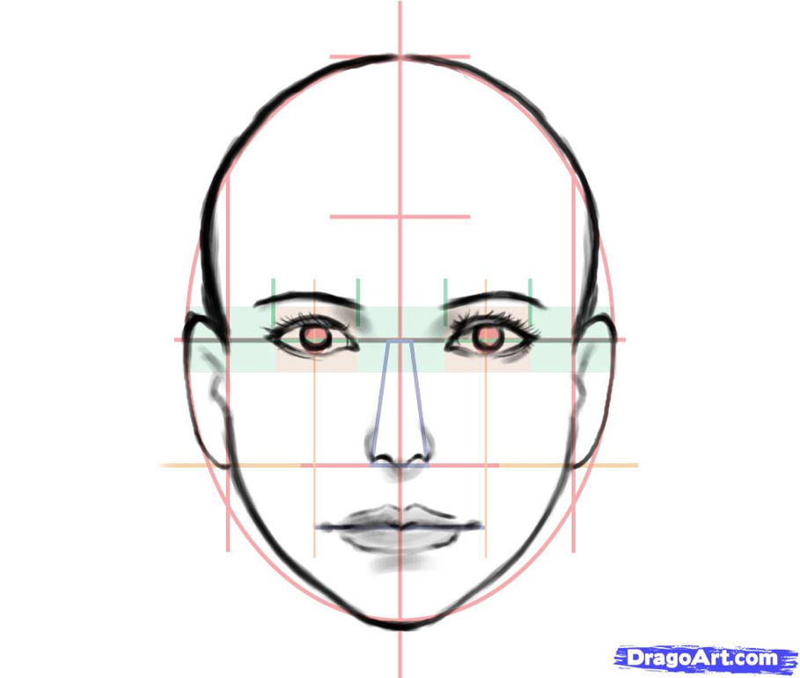
Treatment Record:
BODY TEMPERATURE AT CLINIC

Cost £ ……………………………….

Botulinum Toxin A : ……..…………………… BN : …………..……………. Exp : ……………… (Dilutant: Bacteriostatic 0.9% Sodium Chloride)
Dermal Filler : …………………………………… BN: …………………………. Exp: ……………… Aneasthetic : ……………………………………..
Treatment by Kairen Weston (Advanced Aesthetic Nurse Practitioner, Nurse Prescriber)

Signature …………………………………………………………………..…………… Date ………………………………… JUNE 2021

